1. Test connection using Ping
From the Manage Node, run:
ansible -m ping dev
Here:
- ansible → Ansible command
- -m ping → use the ping module
- dev → run it against the dev host group
Expected:
ansibleclient1 | SUCCESS => {
"changed": false,
"ping": "pong"
}
ansibleclient2 | SUCCESS => {
"changed": false,
"ping": "pong"
}
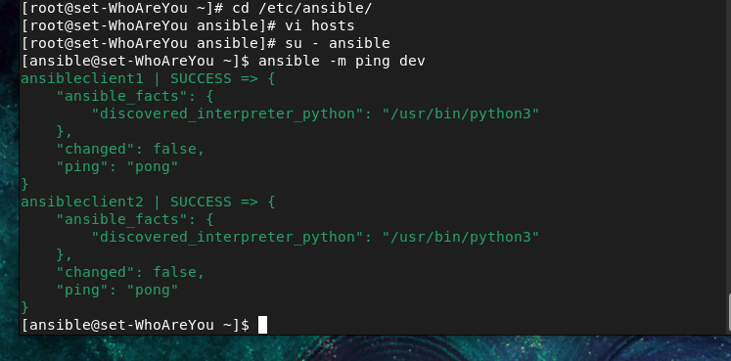

if you change the ec2 you have to do this
That means when you run:
ansible dev1 -m ping
Ansible tries:
dev1
├── ansibleclient1 → SSH → ❌ old host key
└── ansibleclient2 → SSH → ❌ old host key
Because you deleted the old EC2s and created new ones.
Since you are logged in as:
[ansible@localhost ~]$
remove the old keys:
ssh-keygen -R ansibleclient1
ssh-keygen -R ansibleclient2
Then test:
ssh ansible@ansibleclient1
and:
ssh ansible@ansibleclient2
Accept the new fingerprint with yes.
Then make sure passwordless SSH is established:
ssh-copy-id ansible@ansibleclient1
ssh-copy-id ansible@ansibleclient2
Finally:
ansible dev1 -m ping
You want:
ansibleclient1 | SUCCESS => {
"changed": false,
"ping": "pong"
}

ansibleclient2 | SUCCESS => {
"changed": false,
"ping": "pong"
}

2. Check uptime of client machines
ansible dev -m command -a "uptime"
Example output:
ansibleclient1 | CHANGED | rc=0 >>
11:20:10 up 2 days, 3:15, 1 user, load average: 0.00, 0.01, 0.05

ansibleclient2 | CHANGED | rc=0 >>
11:20:15 up 1 day, 5:20, 1 user, load average: 0.00, 0.02, 0.04
Here:
-m command
means use the Ansible command module.
-a "uptime"
means execute the uptime command on the clients.
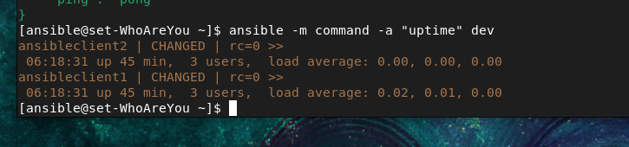

3. Check IP address of the machines
You can use:
ansible dev -m command -a "ip addr"
This displays the network interfaces and IP addresses.
For a simpler output, you can use:
ansible dev -m command -a "hostname -I"
Example:
ansibleclient1 | CHANGED | rc=0 >>
172.31.5.47

ansibleclient2 | CHANGED | rc=0 >>
172.31.5.48

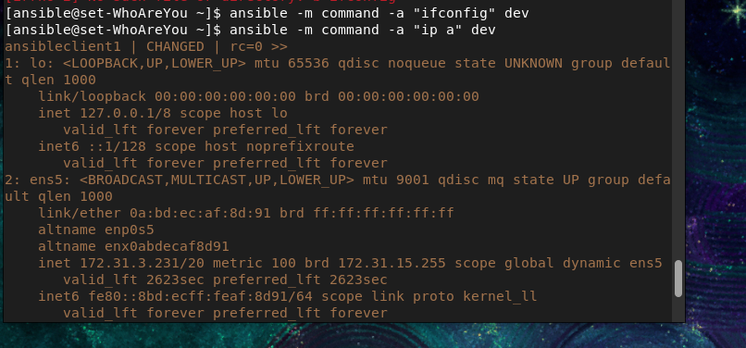

4. Why can't the normal ansible user check firewall status?
Suppose you run:
ansible dev -m command -a "ufw status"
You may get:
ERROR: You need to be root to run this command
This happens because ufw status requires root privileges.
Your Ansible user is a normal user.


5. Give ansible sudo permission
You need to configure this on both client machines.
Log in to each client as root:
su -
Then open the sudoers file safely:
visudo
Find:
# User privilege specification
Add:
ansible ALL=(ALL) NOPASSWD: ALL
Save and exit.
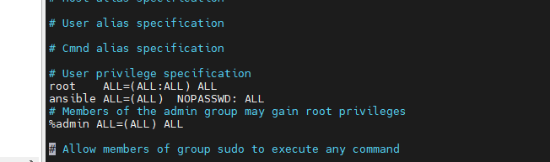
Meaning
ansible
→ the user
ALL
→ can use this permission from any host
(ALL)
→ can run commands as any user, including root
NOPASSWD:
→ don't ask for the sudo password
ALL
→ all commands are allowed
So:
ansible ALL=(ALL) NOPASSWD: ALL
basically means:
The ansible user can run any command with sudo/root privileges without entering a password.

6. Run the firewall command with --become
From the Manage Node:
ansible dev -m command -a "ufw status" --become



